

CHAMPVA Other Health Insurance (OHI) Certification  
Form 10-7959c

(Debut Date) February 24, 2025 |

Version 1

Revision History

| Date | Version | Description | Author |
| --- | --- | --- | --- |
| 2/20/25 | 1 | Product Debut | Bo Altes |
|  |  |  |  |

Table of Contents

**Overview 4**

**Signed/in/signed out states 7**

**Introduction 8**

**Step 1: Signer Information 9**

**Step 2: Beneficiary information 10**

**Step 3: Medicare information 11**

**Step 4: Health insurance information 12**

**Step 5: File upload 14**

**Step 6: Review and sign 15**

**Error messages 20**

## Overview

VA.gov users who are the spouse or child of a Veteran with disabilities or a Veteran who has died may be able to get health insurance through the Civilian Health and Medical Program of the Department of Veterans Affairs (CHAMPVA). As part of CHAMPVA users who have other health insurance (including Medicare) need to submit a completed CHAMPVA-Other Health Insurance Certification (VA Form 10-7959c) as well as a copy of the front and back of their health insurance card or Medicare card. Users can log in or can access and fill out the form without signing in.

The form can be accessed directly through this URL: <https://www.va.gov/family-and-caregiver-benefits/health-and-disability/champva/submit-other-insurance-form-10-7959c/introduction>

It can also be found from the health care home page <https://www.va.gov/health-care/>:

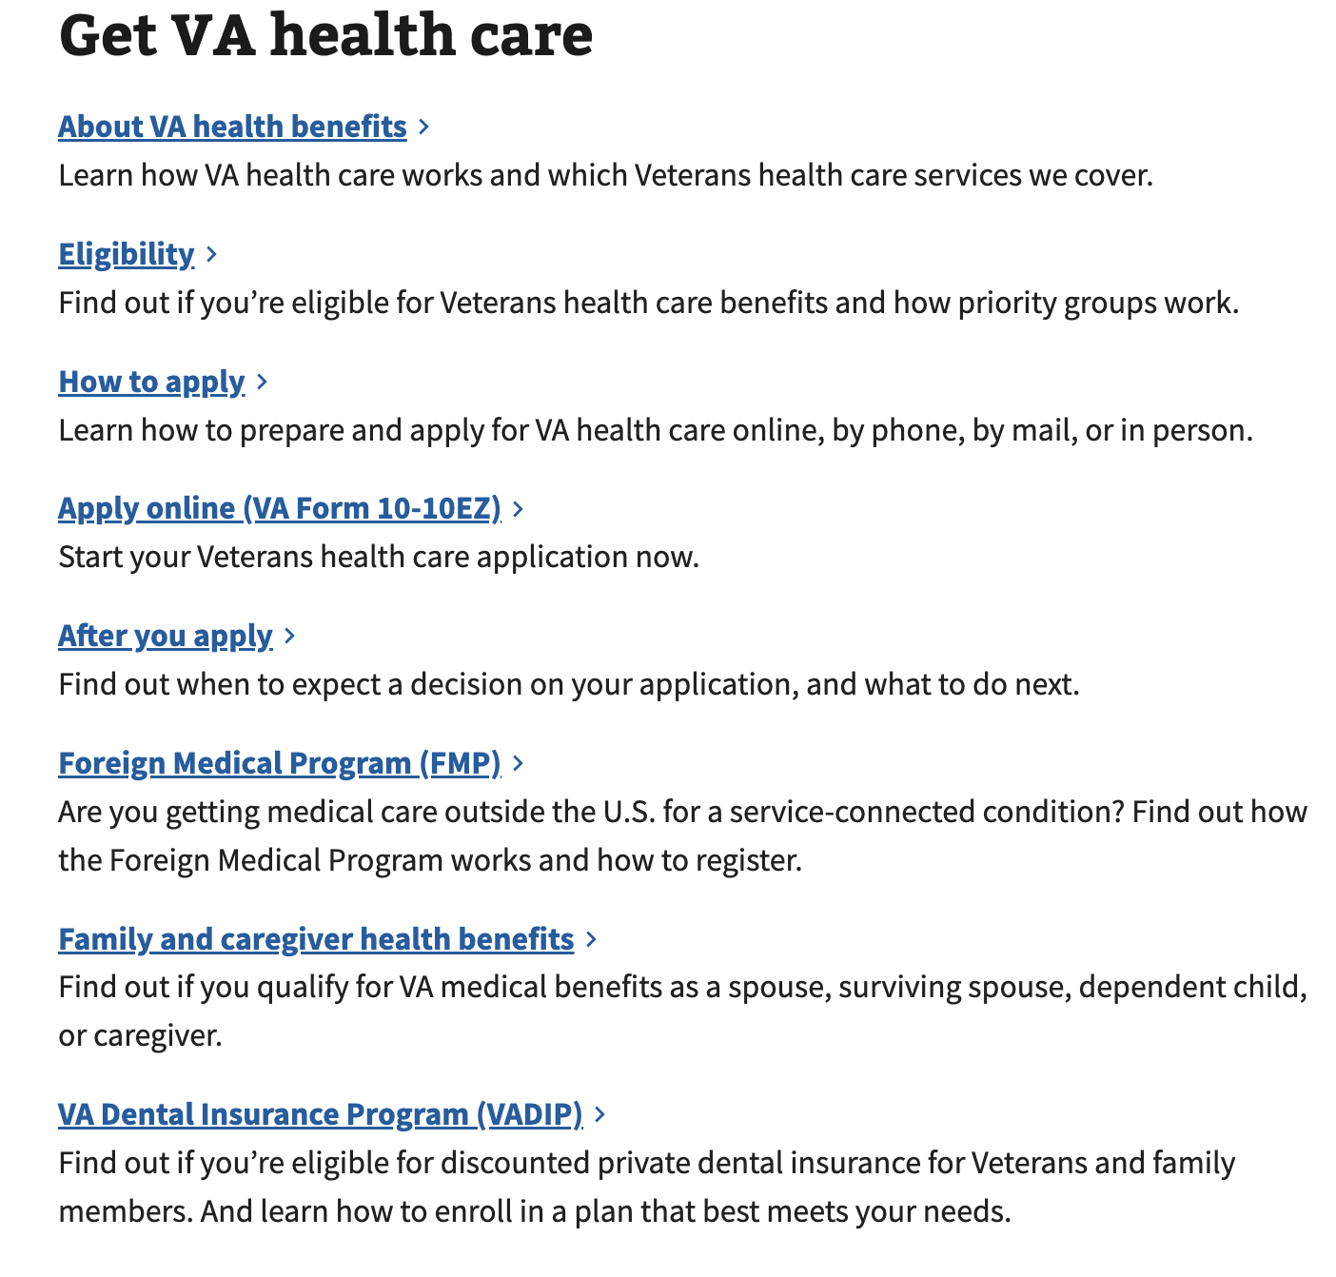

Navigating from the Family and caregiver health benefit link on the health care home page leads to the Health care for spouses, dependents, and family caregivers page.



Clicking on the “CHAMPVA benefits” link will take the user to the CHAMPVA Benefits page, and follow the link for “Support documents for your application.”

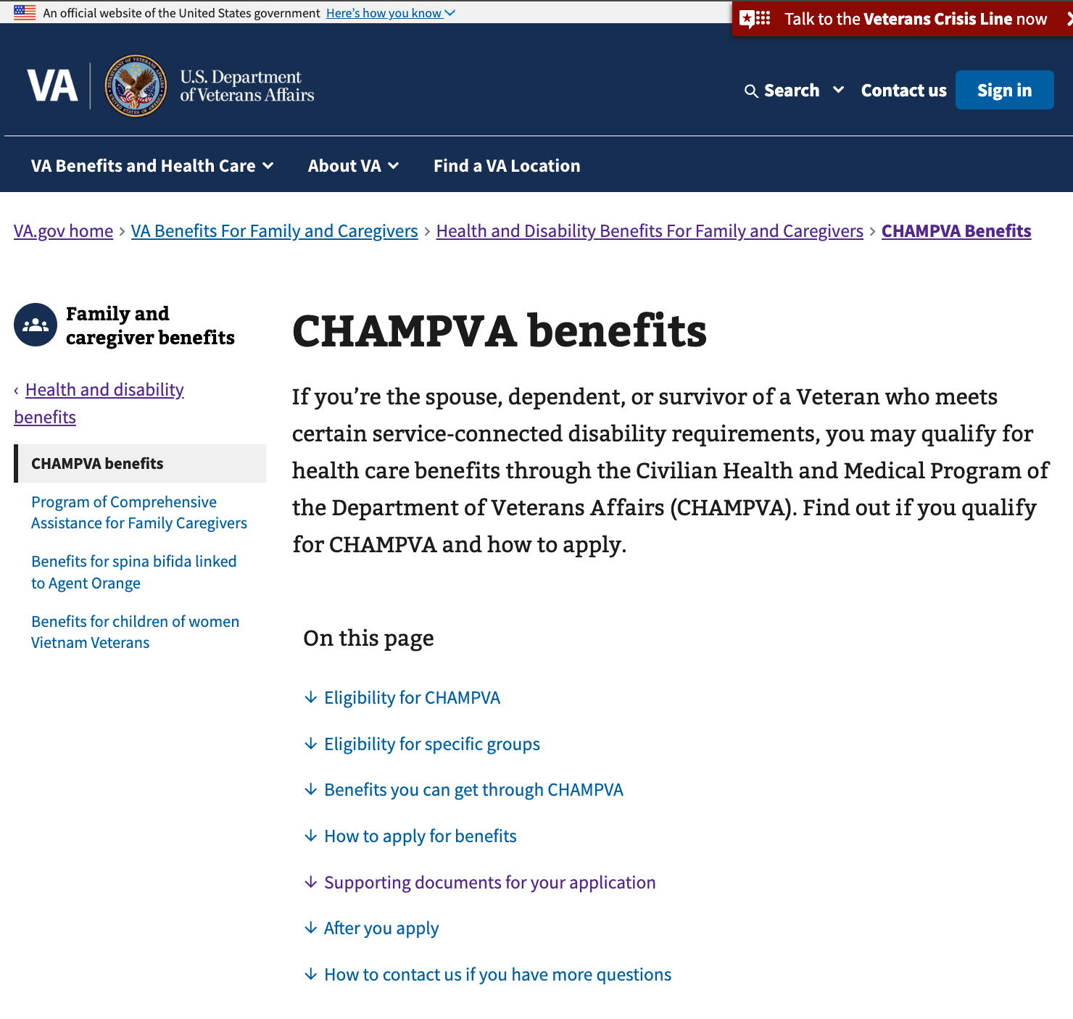  
  
Form 10-7959c can be found in this section and can also be accessed directly at <https://staging.va.gov/family-and-caregiver-benefits/health-and-disability/champva/submit-other-insurance-form-10-7959c/introduction>

### Steps for this form:

1. Signer information
   1. I’m filling out this form for myself
   2. I’m a parent, spouse, or legal representative signing on behalf of the beneficiary
2. Beneficiary information
   1. Name
   2. Identification
   3. Mailing address
   4. Phone number
   5. Sex listed at birth
3. Medicare information
   1. Medicare status
   2. Your Medicare coverage
   3. Your Medicare Part A carrier
   4. Your Medicare Part A carrier
   5. Upload Medicare card for hospital and medical coverage
   6. Your Medicare Part D status
   7. Your Medicare Part D carrier
   8. Upload Medicare Part D card
4. Health insurance information
   1. Your health insurance
   2. Your insurance plan
   3. Your health insurance information
   4. Your type of insurance
   5. Your prescription coverage
   6. Upload health insurance card
   7. Your health insurance additional comments
   8. Your additional health insurance
5. File Upload
   1. Upload your supporting documents
   2. Supporting documents summary

## Signed/in/signed out states

* Signed out users can access the registration form through the introduction page. If they follow the unauthorized flow and are not signed into their VA.gov profile, they will not be able to save their progress if they leave the form before submitting.
* If the user signs in, they will be taken to the sign in screen and then able to save their progress when filling out the form.

## Introduction

To start the form, click the call to action on the introduction page:

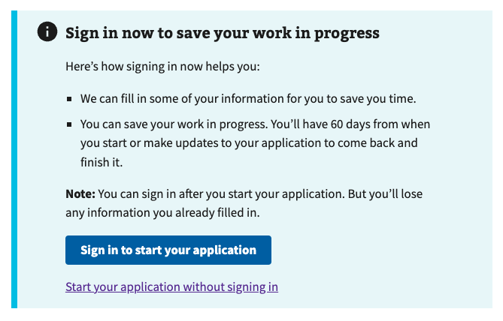

## Step 1: Signer Information

The user is prompted to choose an option that best describes them.

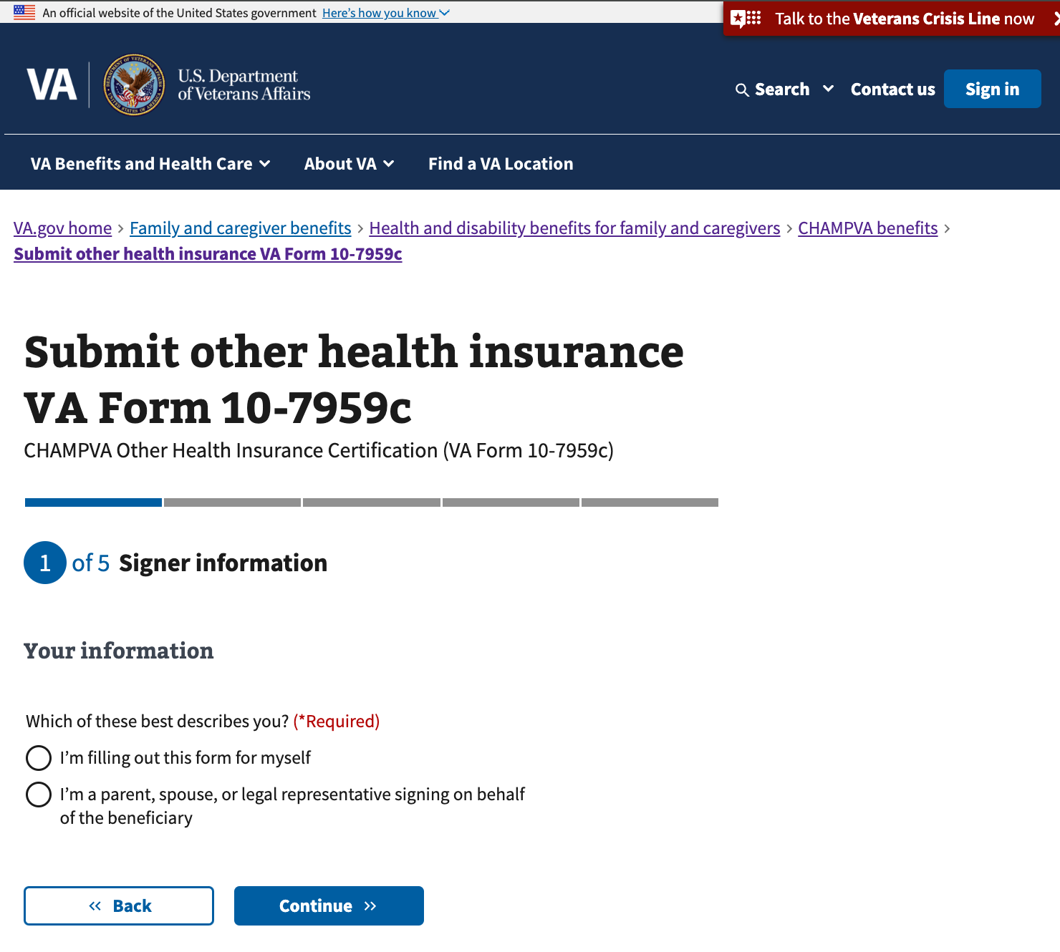

### Option A: I’m filling out this form for myself

If the user selects “I’m filling out this form for myself,” they will proceed to the next section.

### Option B: I’m a parent, spouse, or legal representative signing on behalf of the beneficiary

If the user selects “I’m a parent, spouse, or legal representative signing on behalf of the beneficiary,” they will be asked to provide their email address on the next screen before proceeding to the “Beneficiary information” section. The signer’s email address is kept on record in case of any problems with their form.

## Step 2: Beneficiary information

### Name

The user must enter information about the beneficiary. The beneficiary’s first name and last name are required.

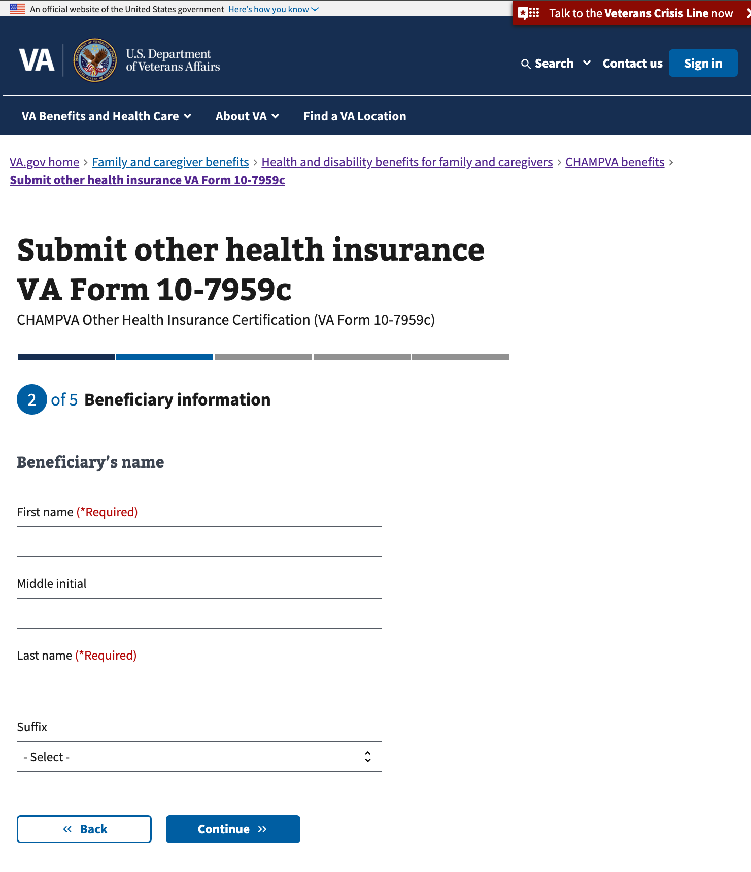

### Identification

The user must enter the beneficiary’s social security number.

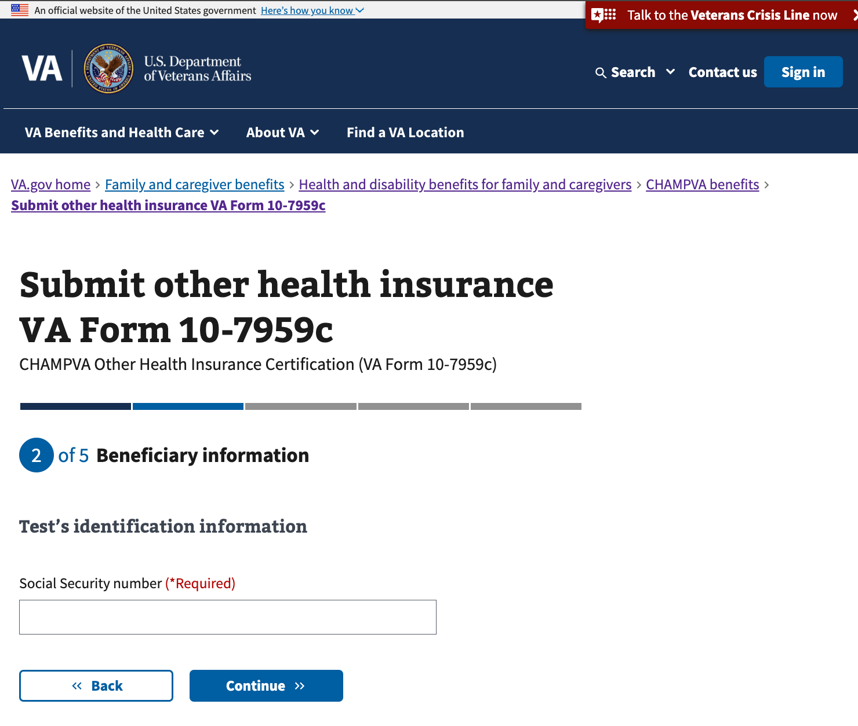

### Mailing address

The user must enter a mailing address for the beneficiary. The user is also asked whether the beneficiary’s address has changed since their last form submission. The answer to this question is used during processing but does not affect how the user proceeds through the rest of the form..

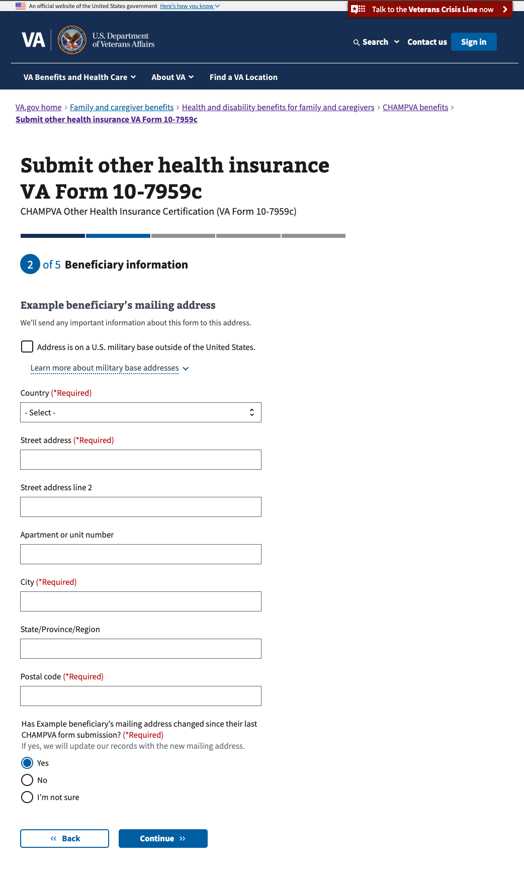

### Phone number

The user must enter the beneficiary’s phone number. If someone other than the beneficiary is filling out the form on behalf of the beneficiary, they will have the option of entering the beneficiary’s email address in addition to their own.

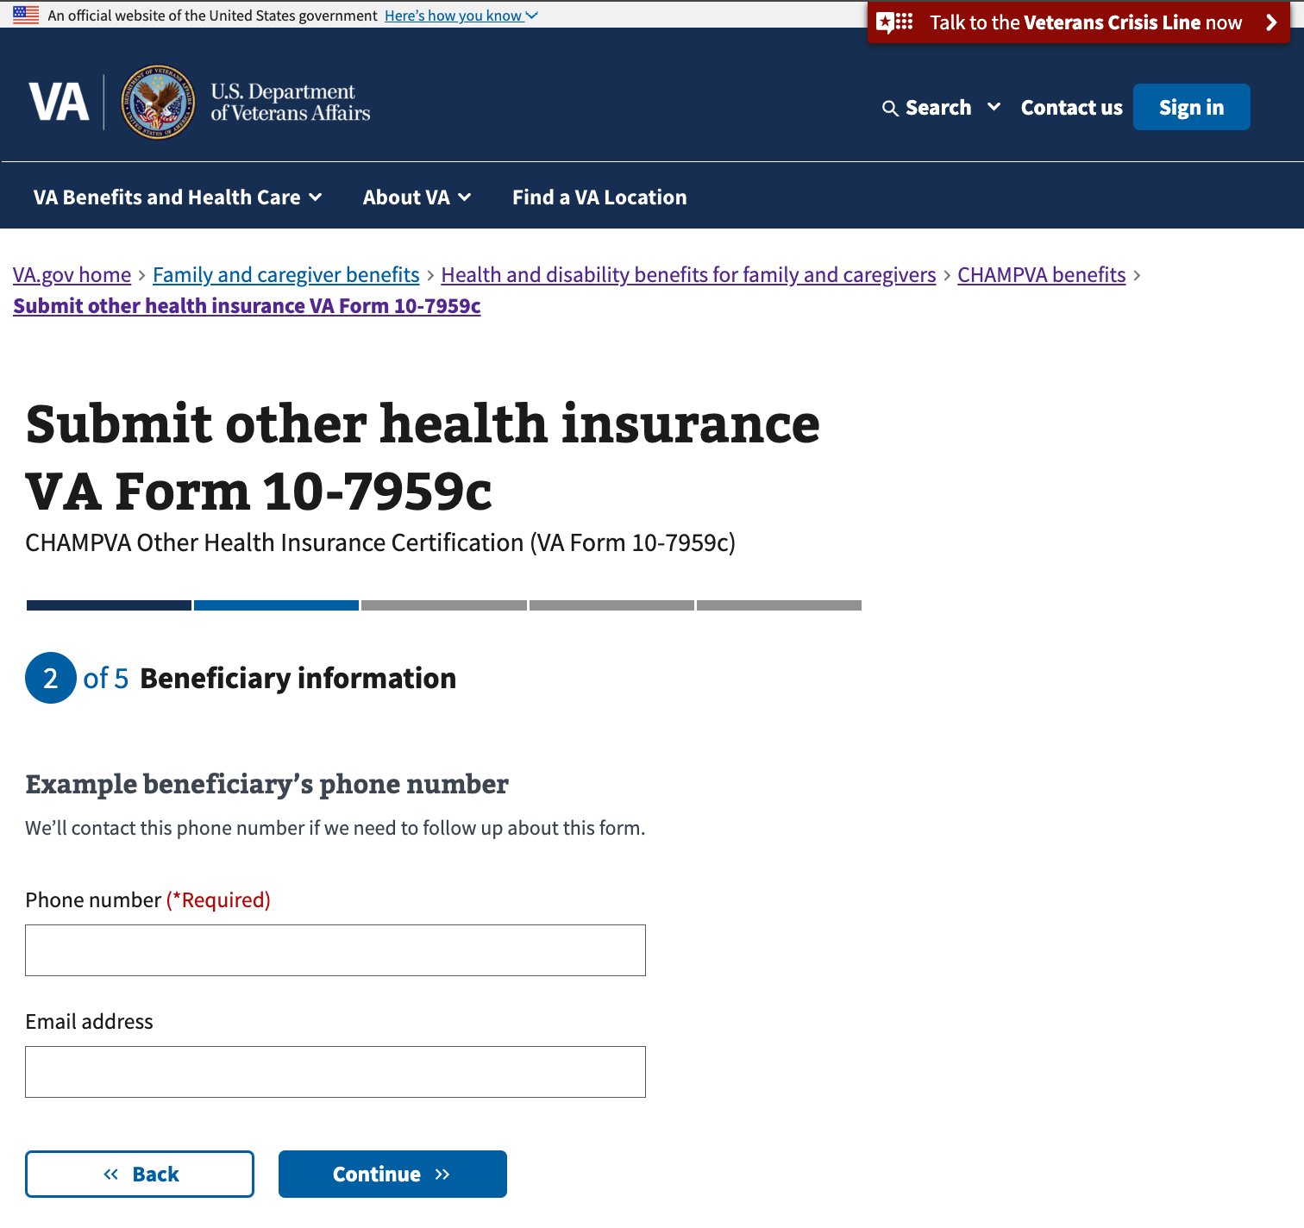

### Sex listed at birth

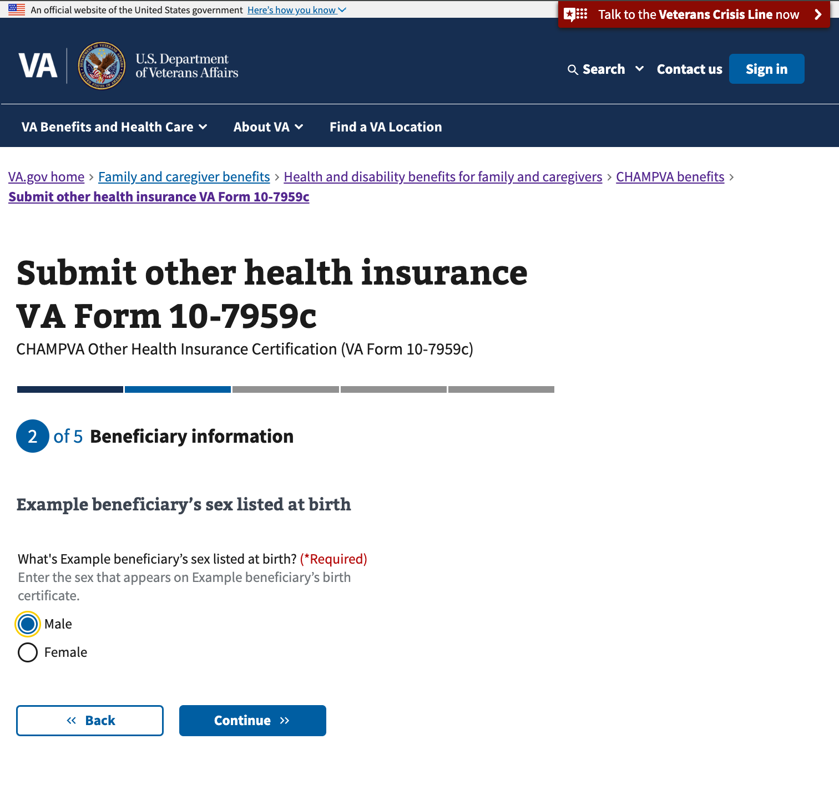

The user will then proceed to the Medicare information section.

## Step 3: Medicare information

### Medicare status

The user is required to indicate whether or not the beneficiary has Medicare information to provide or update and may answer yes or no. If they answer no, they will proceed to the next section of the form. If the answer is yes, they will proceed through the following screens to provide their information.

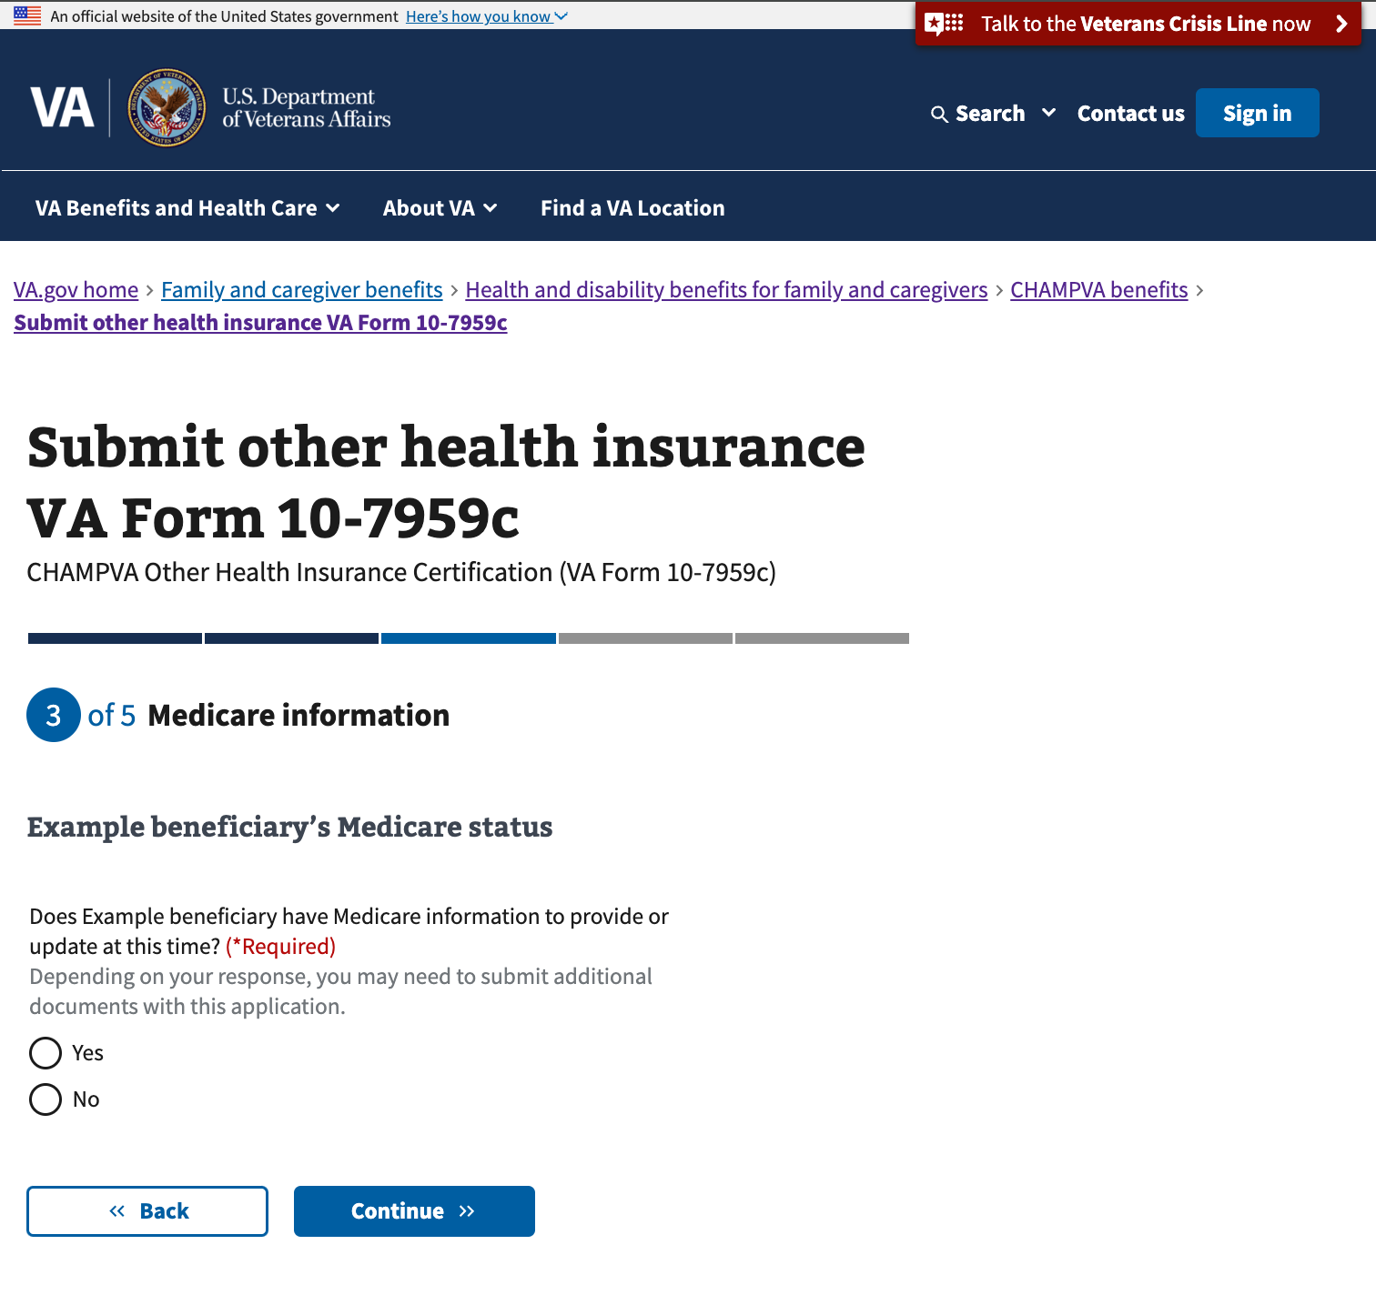

### Your Medicare coverage

The user must indicate which plan the beneficiary is enrolled in.

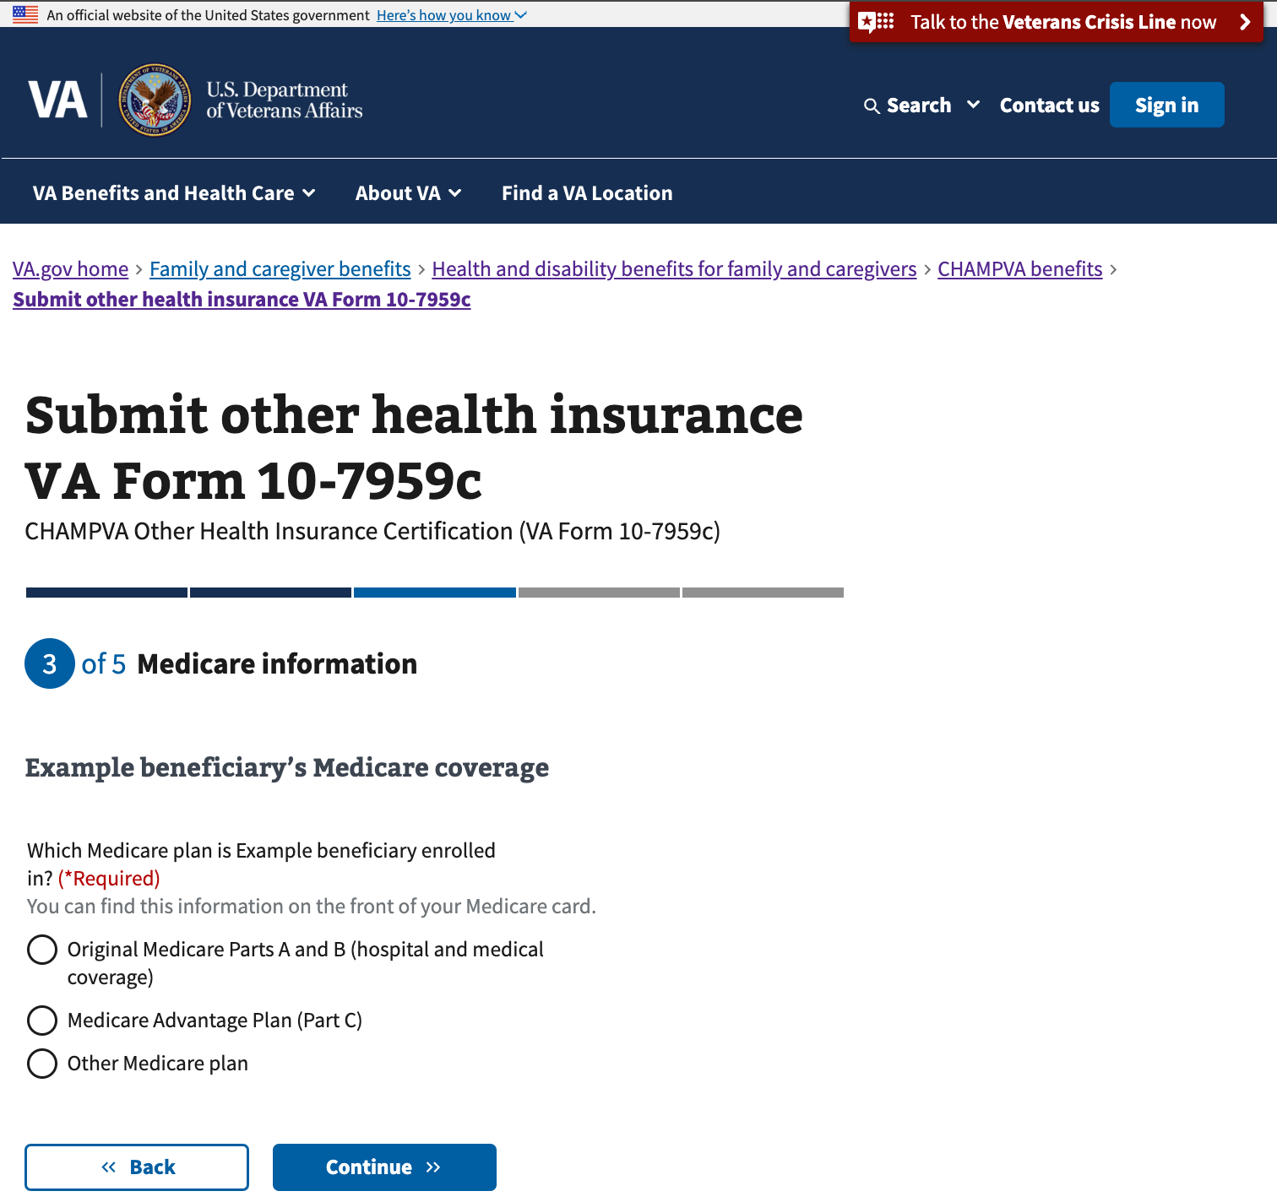

### Your Medicare Part A carrier

The user must enter the name of the Medicare insurance carrier and the effective date of the plan.

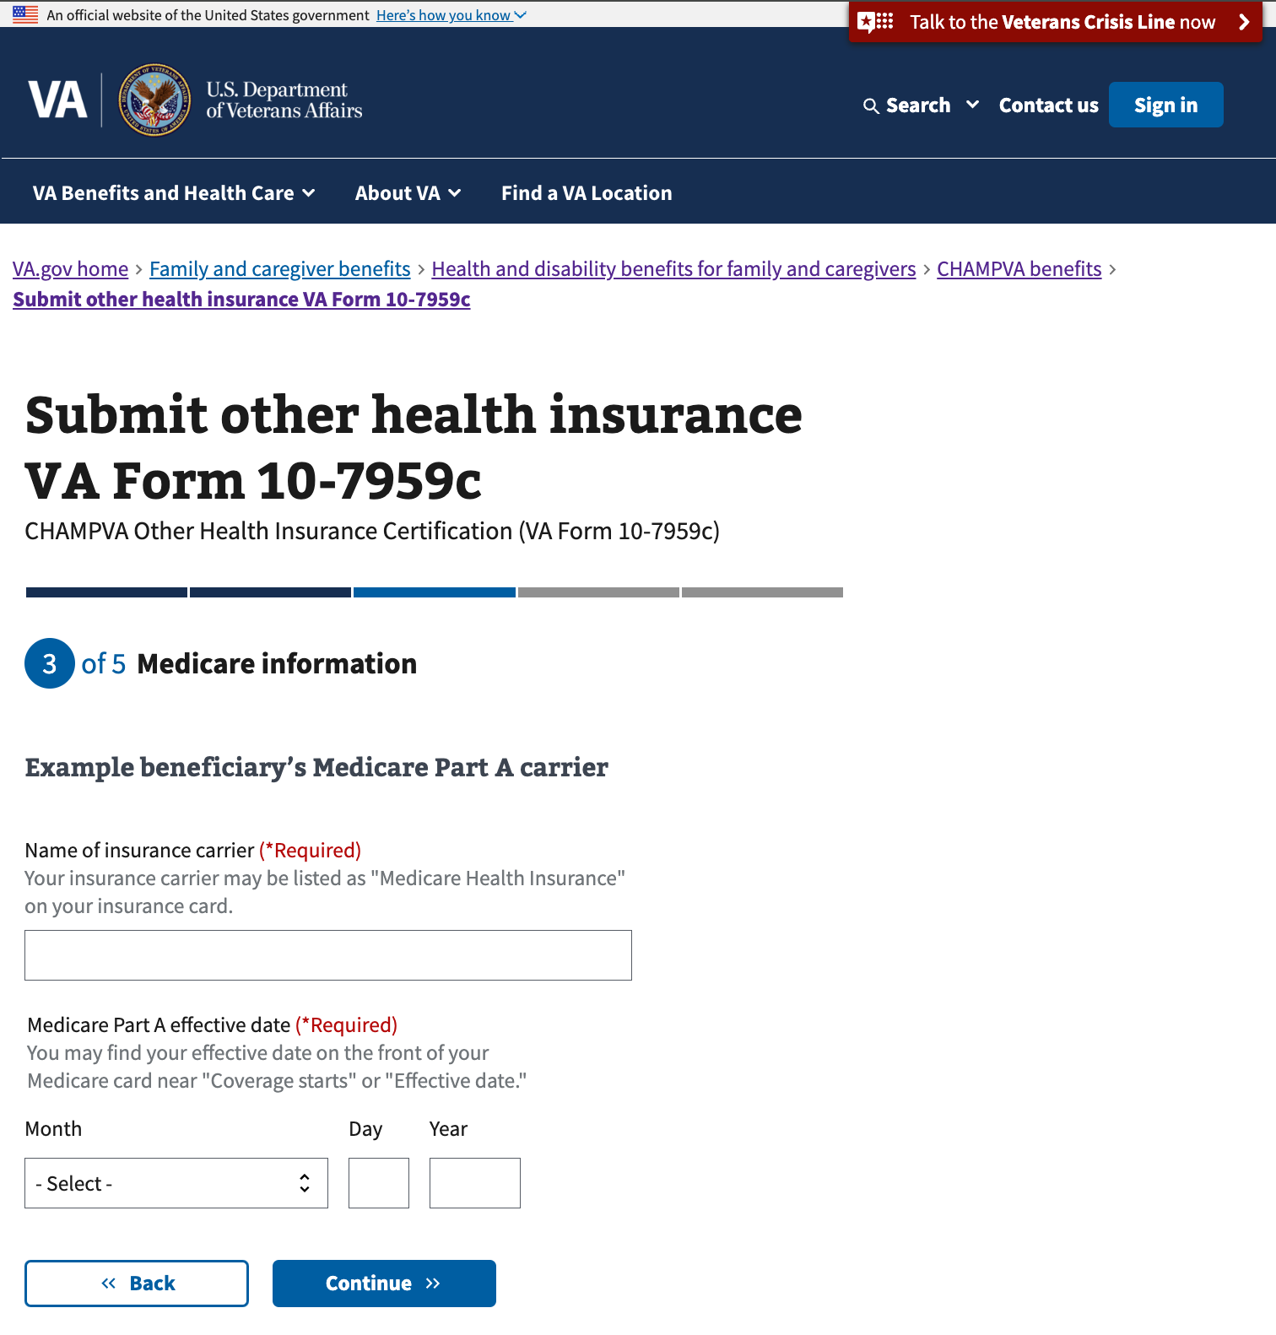

### Your Medicare Part B carrier

The user must enter the name of the Medicare insurance carrier and the effective date of the plan.

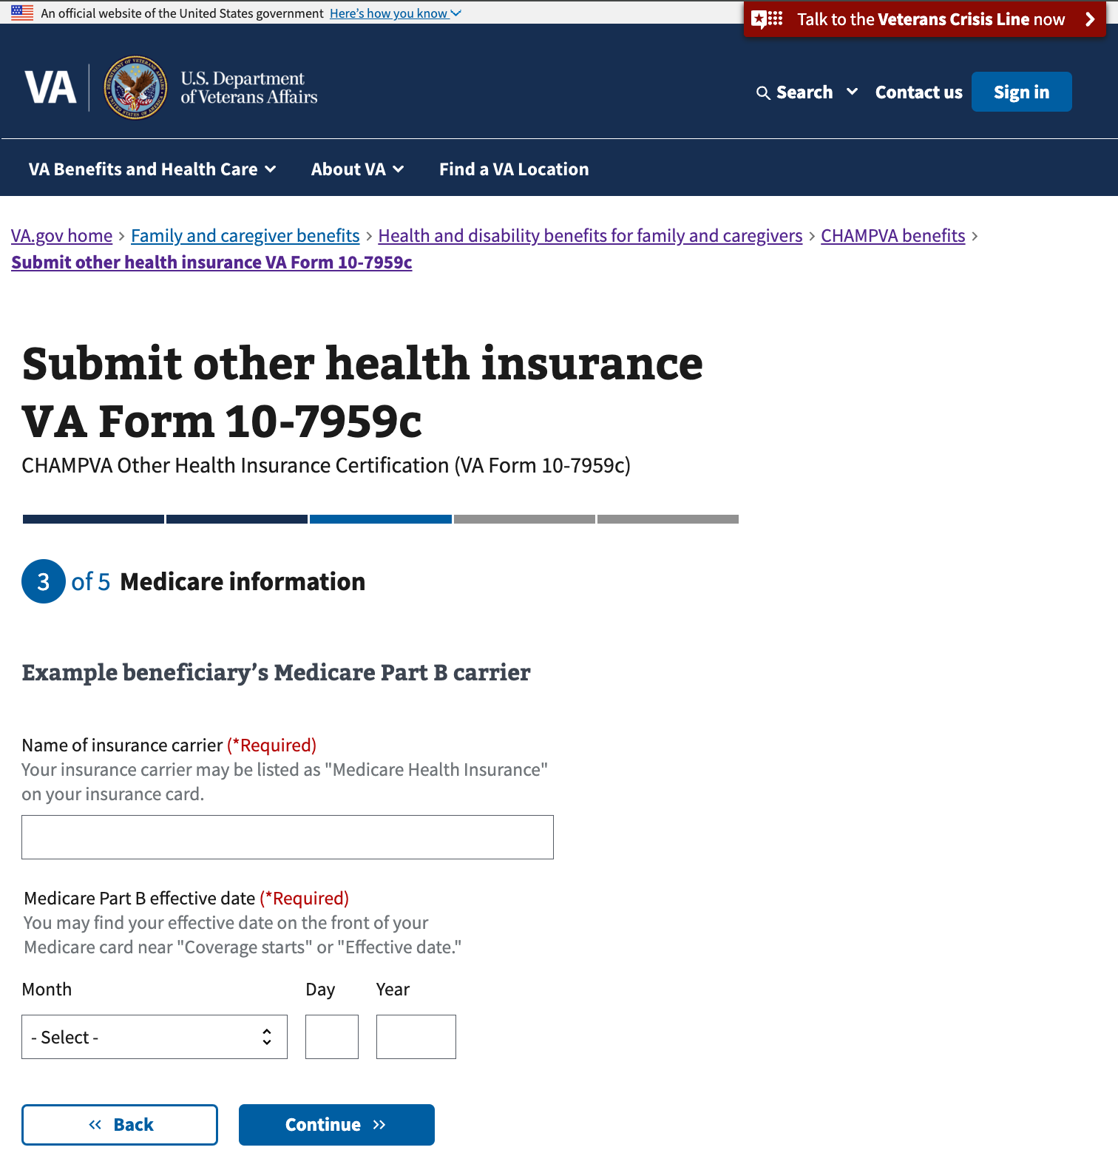

### Upload Medicare card for hospital and medical coverage

The user is prompted to provide a copy of their insurance card. This step is optional but will help with the processing of their form. They will also have an opportunity to upload later in the form if they choose.

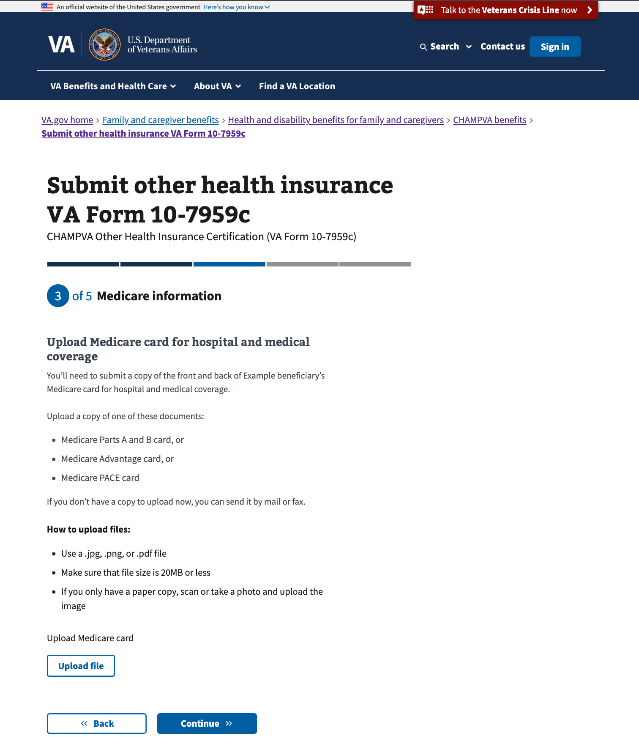

### Your Medicare Part D status

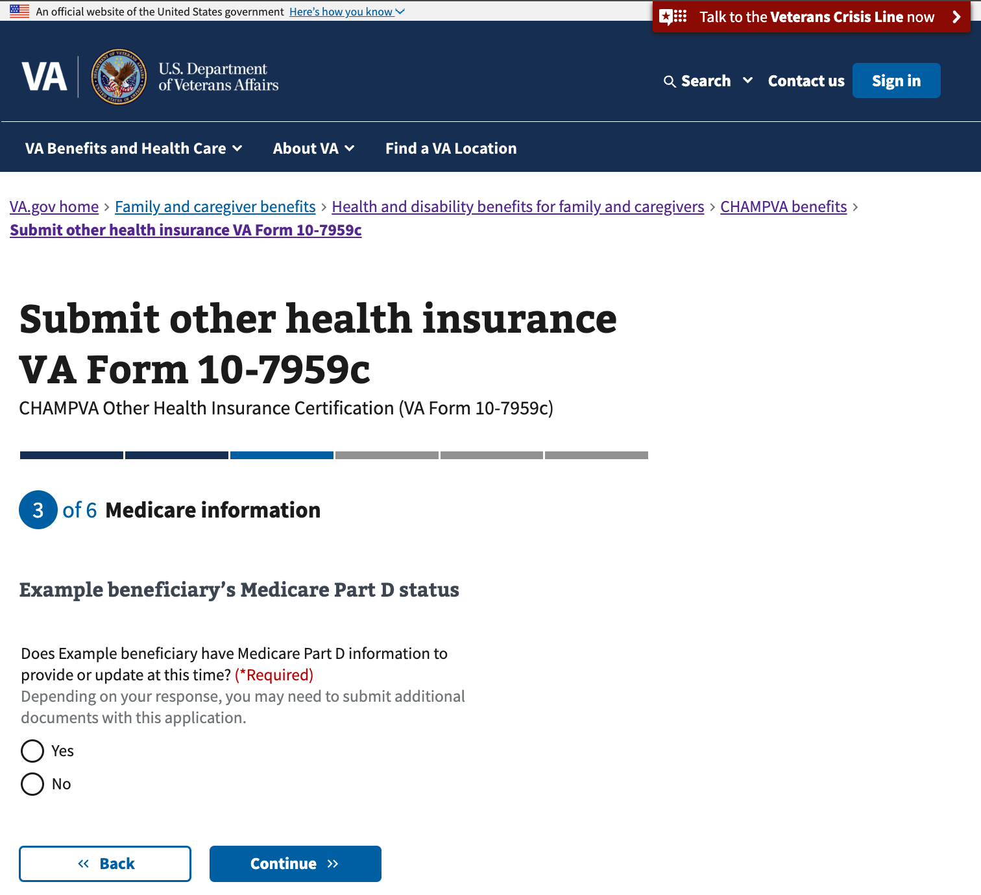

### Your Medicare Part D carrier

The user must enter the name of the Medicare insurance carrier and the effective date of the plan.

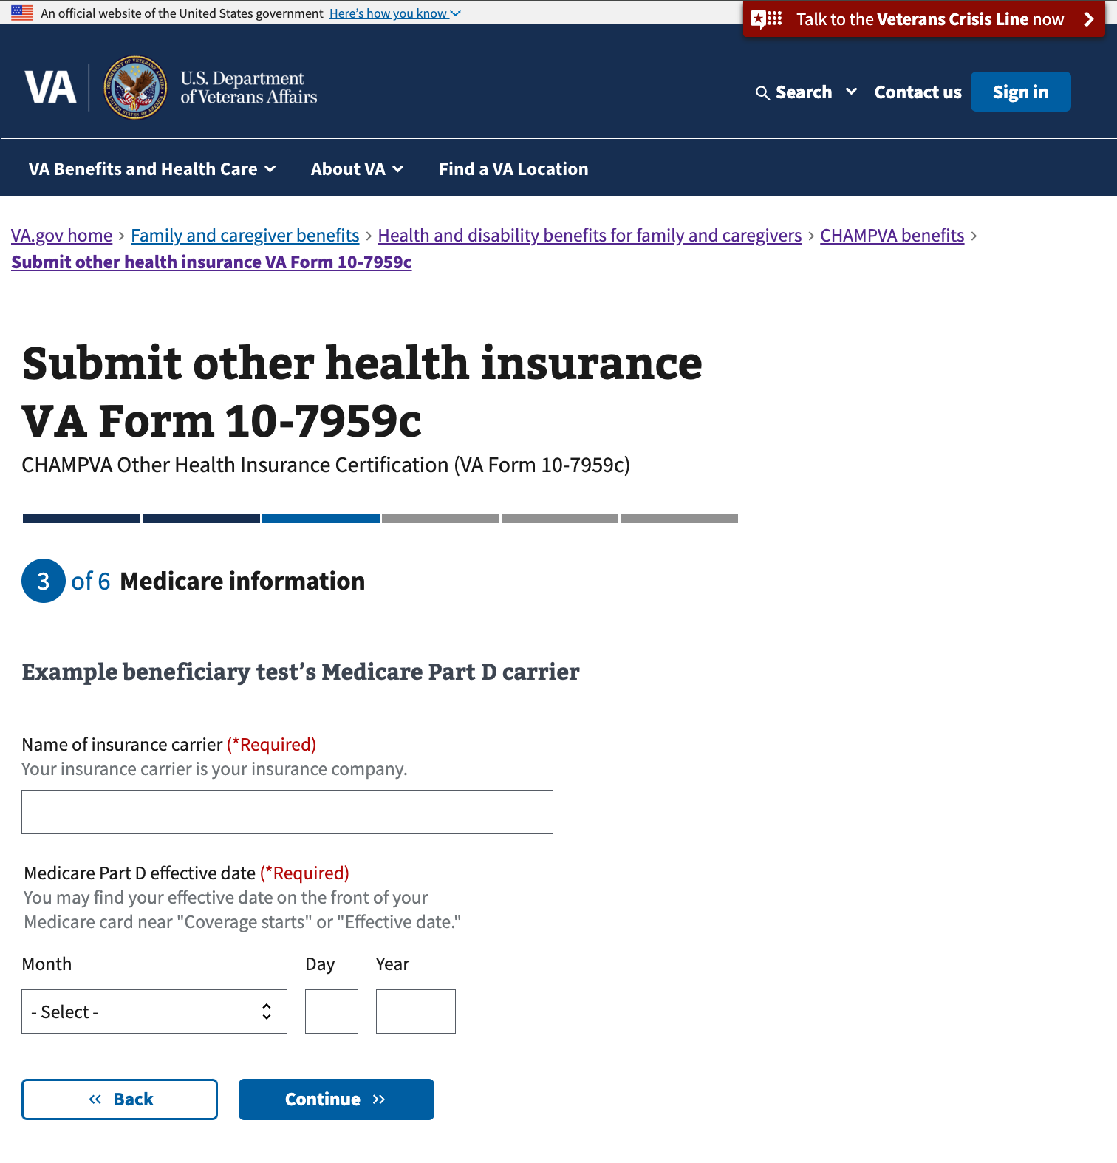

### Upload Medicare Part D card

The user is prompted to provide a copy of their insurance card. This step is optional but will help with the processing of their form. They will also have an opportunity to upload later in the form if they choose.

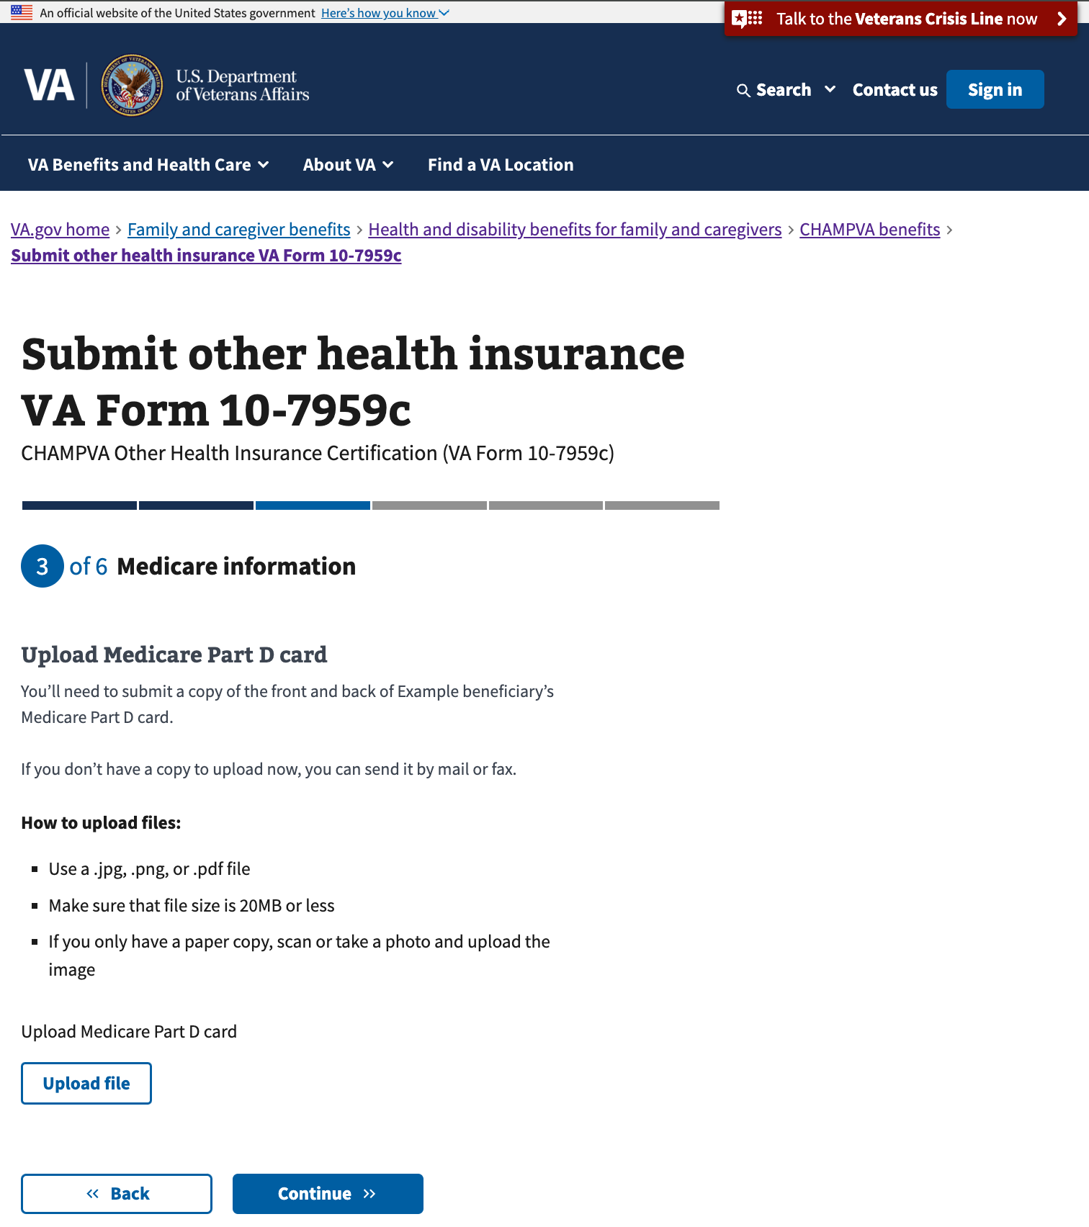

## 

## Step 4: Health insurance information

### Your health insurance

The user is prompted to indicate whether they have additional health insurance information to provide or update.

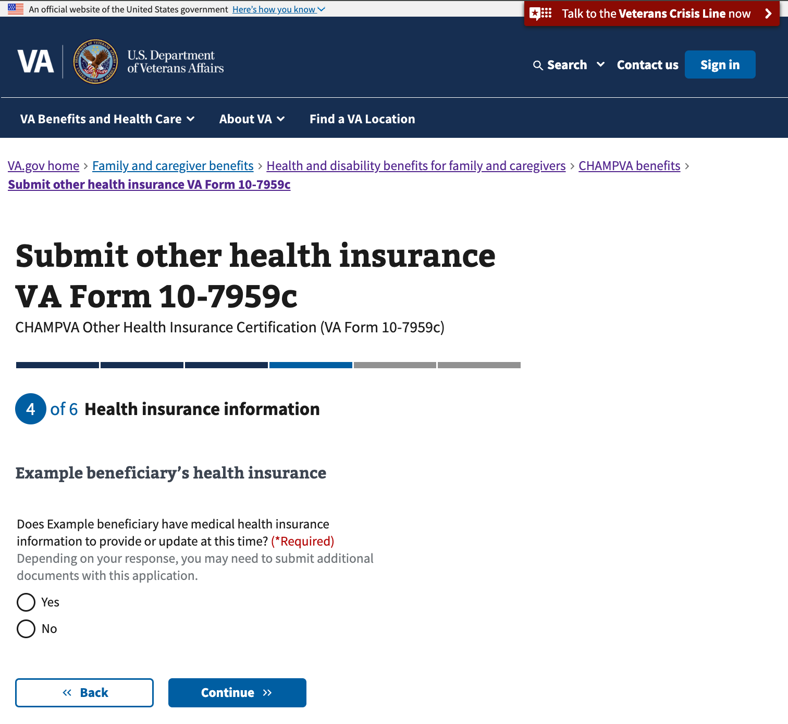

### Your insurance plan

The user is prompted to indicate the type of insurance plan.

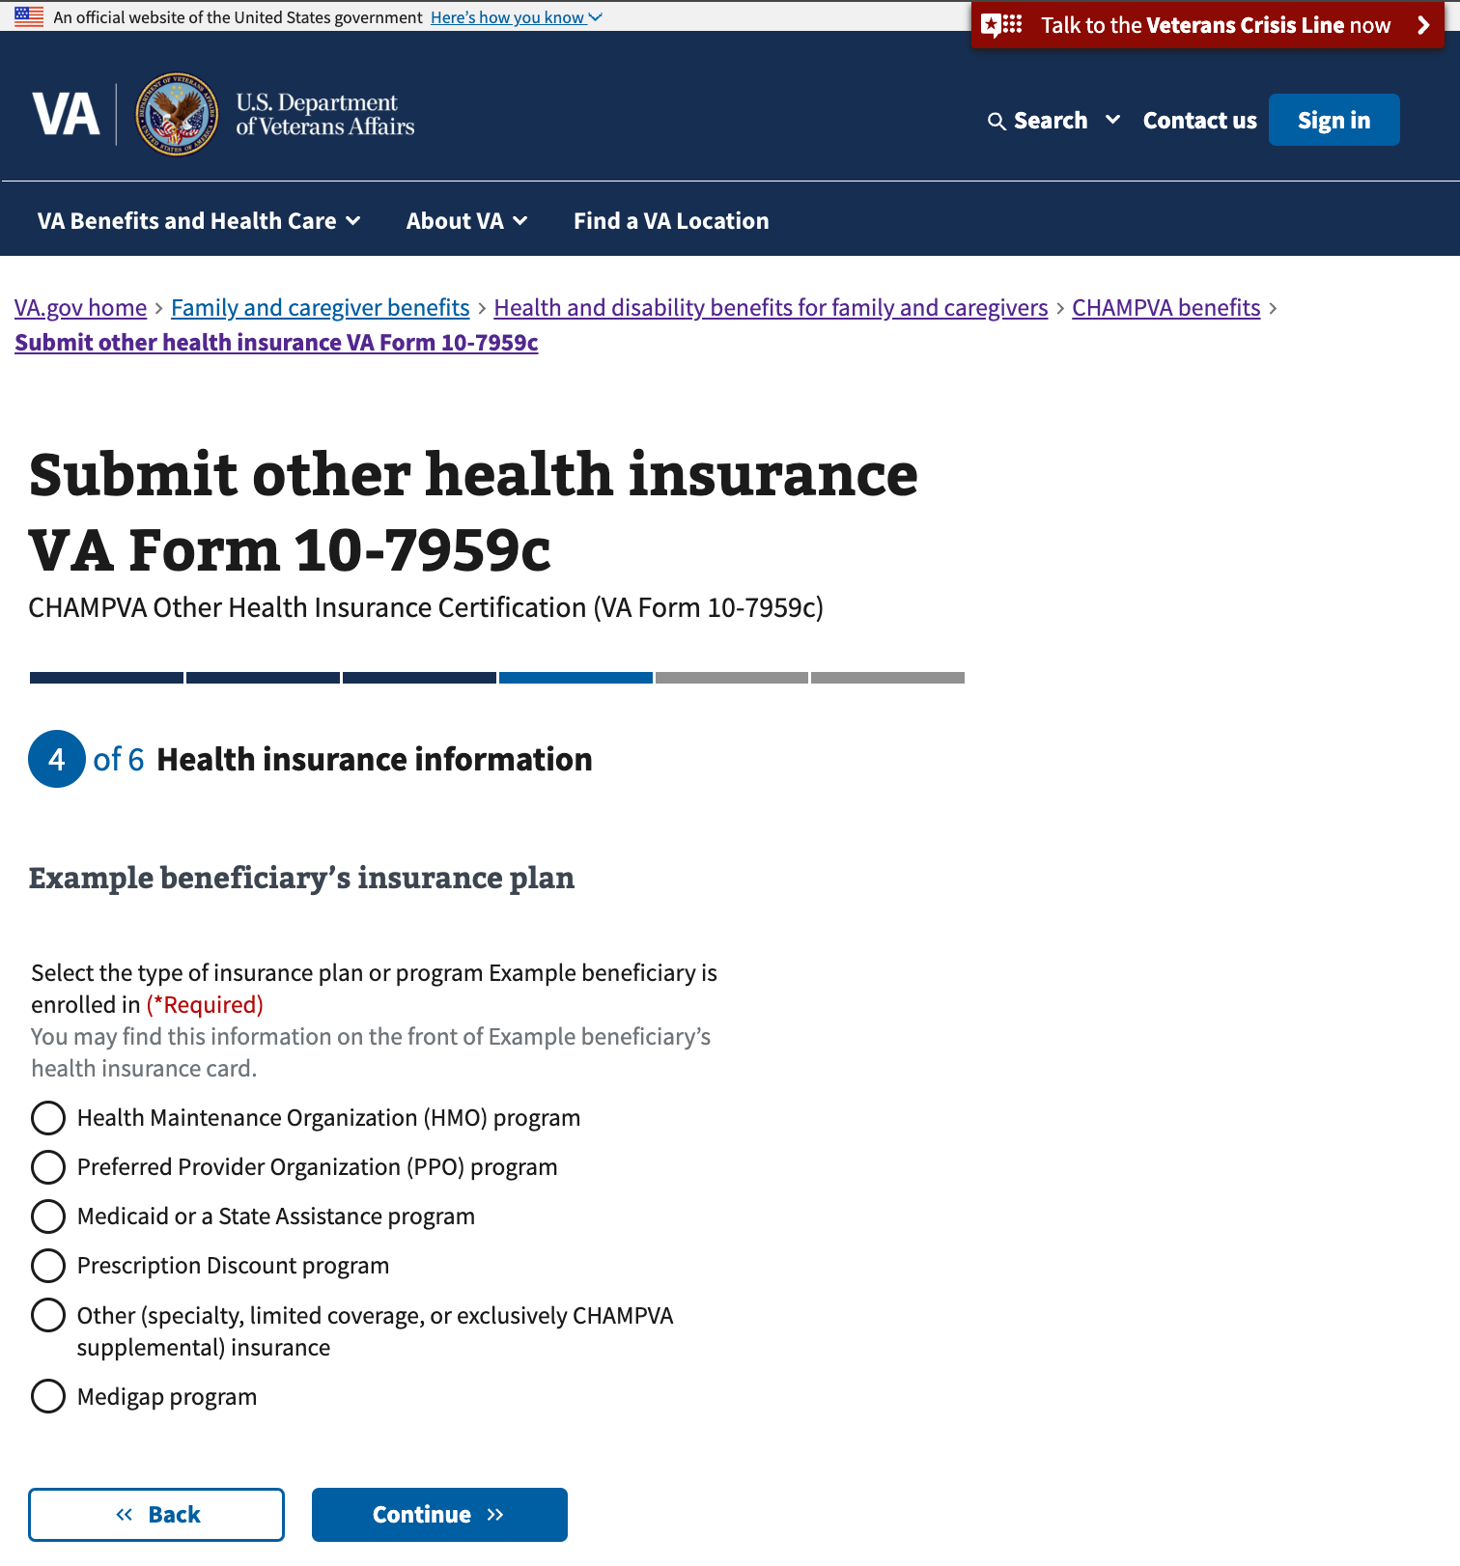

### Your health insurance information

The user must enter the name of the insurance provider and the effective date of the plan.

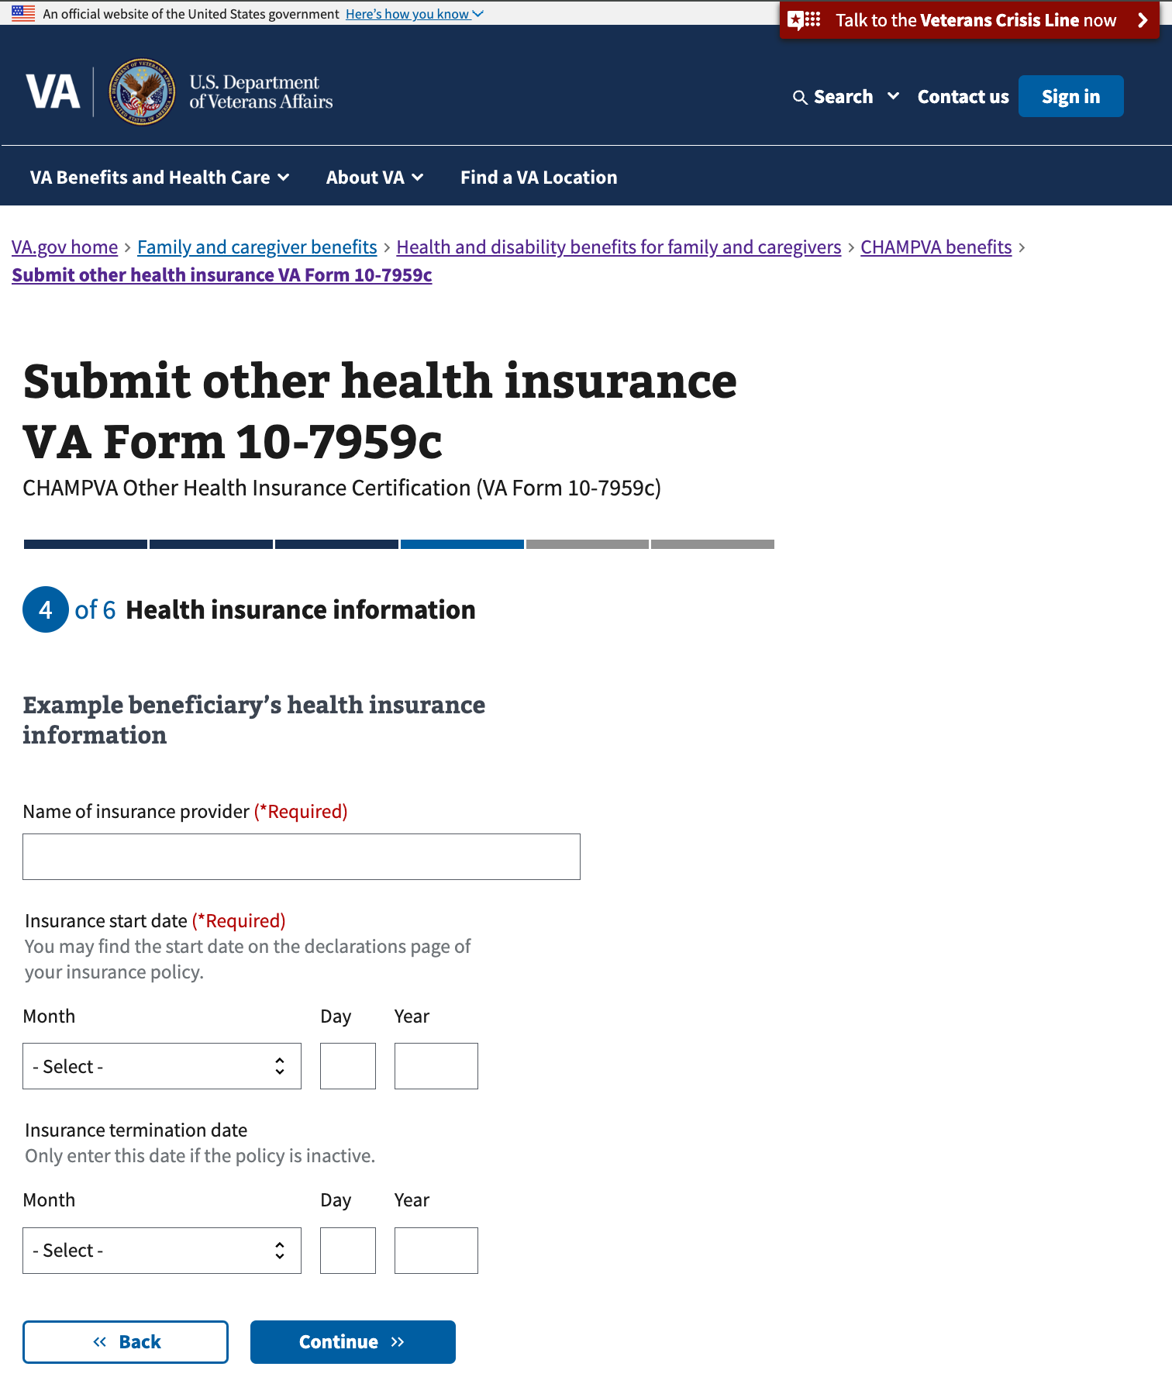

### Your type of insurance

The user is prompted to indicate whether the beneficiary’s insurance is through the beneficiary’s employer.

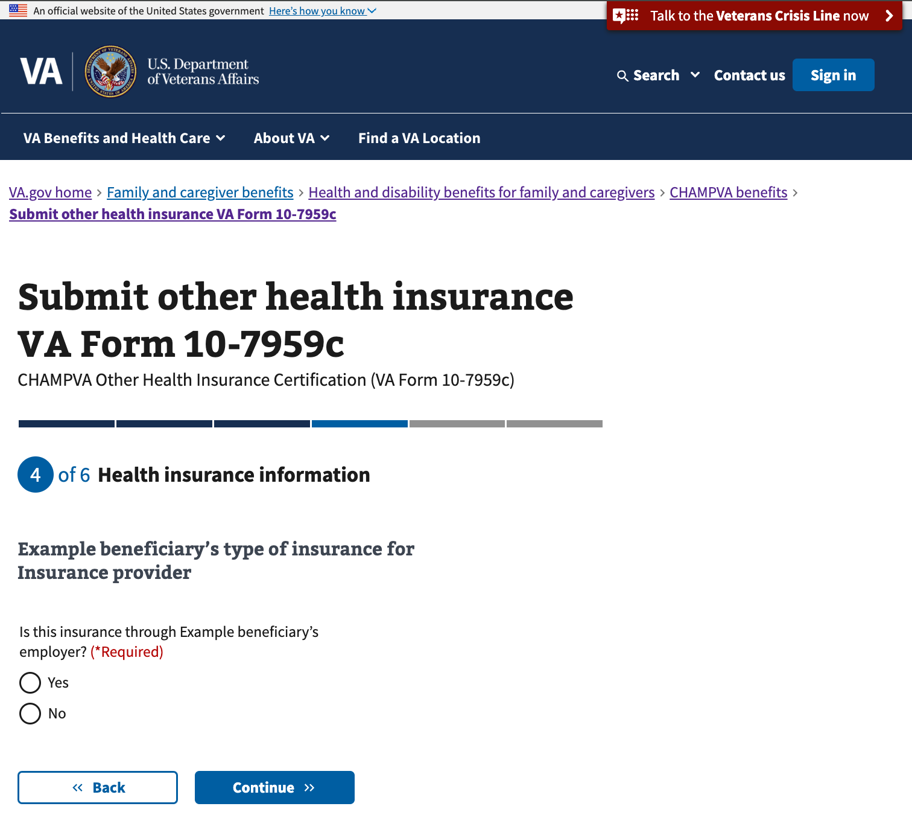

### Your prescription coverage

The user is prompted to indicate whether insurance covers prescriptions.

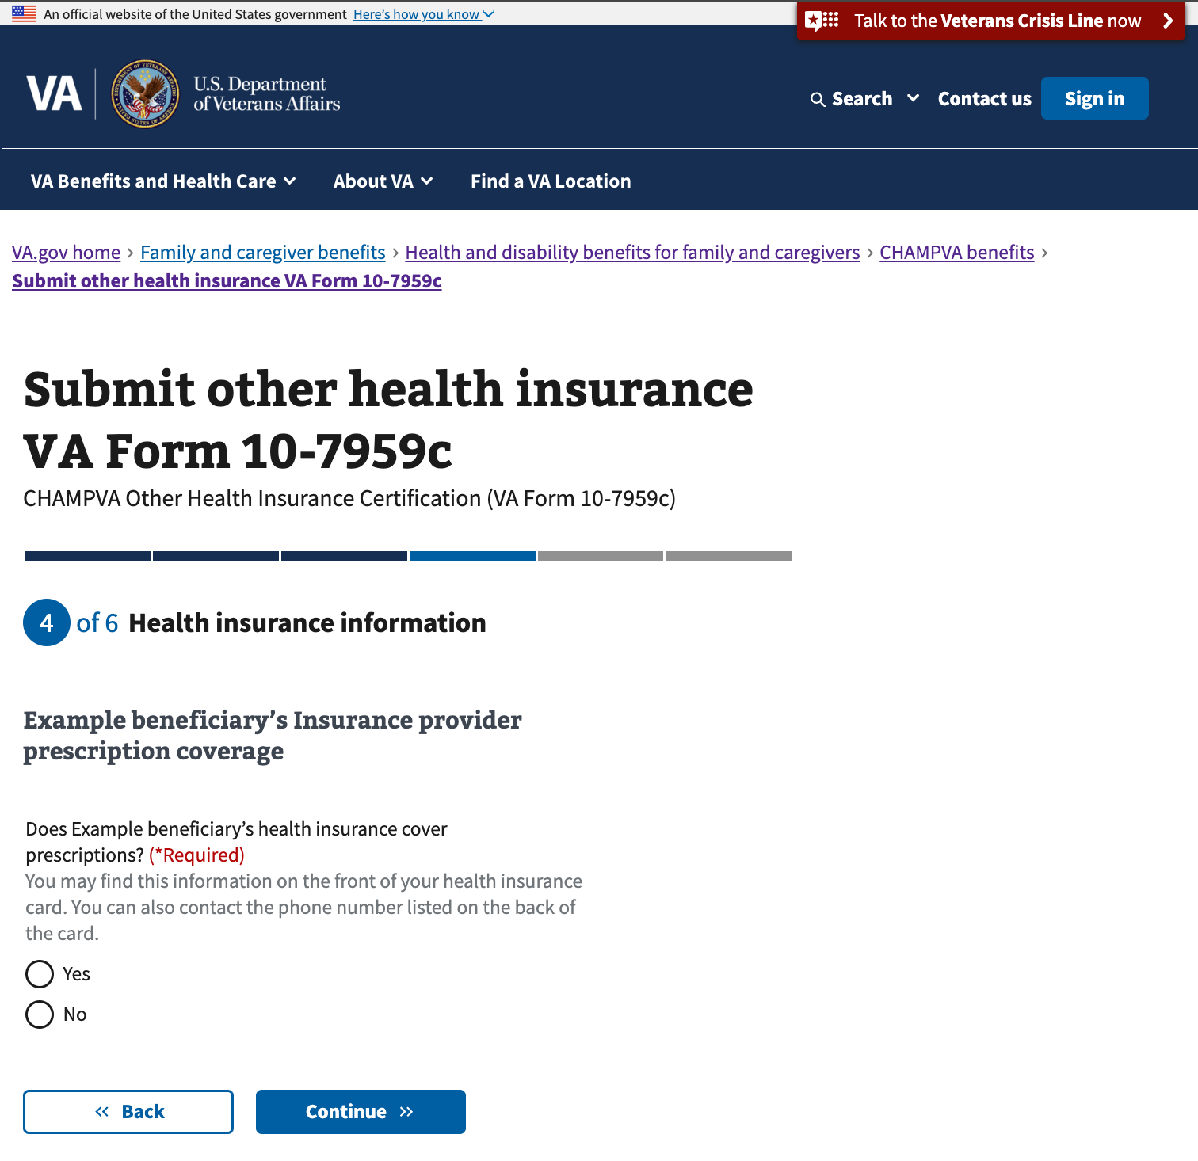

### Your insurance provider explanation of benefits

The user is prompted to indicate whether the beneficiary’s insurance plan has an explanation of benefits for prescriptions.

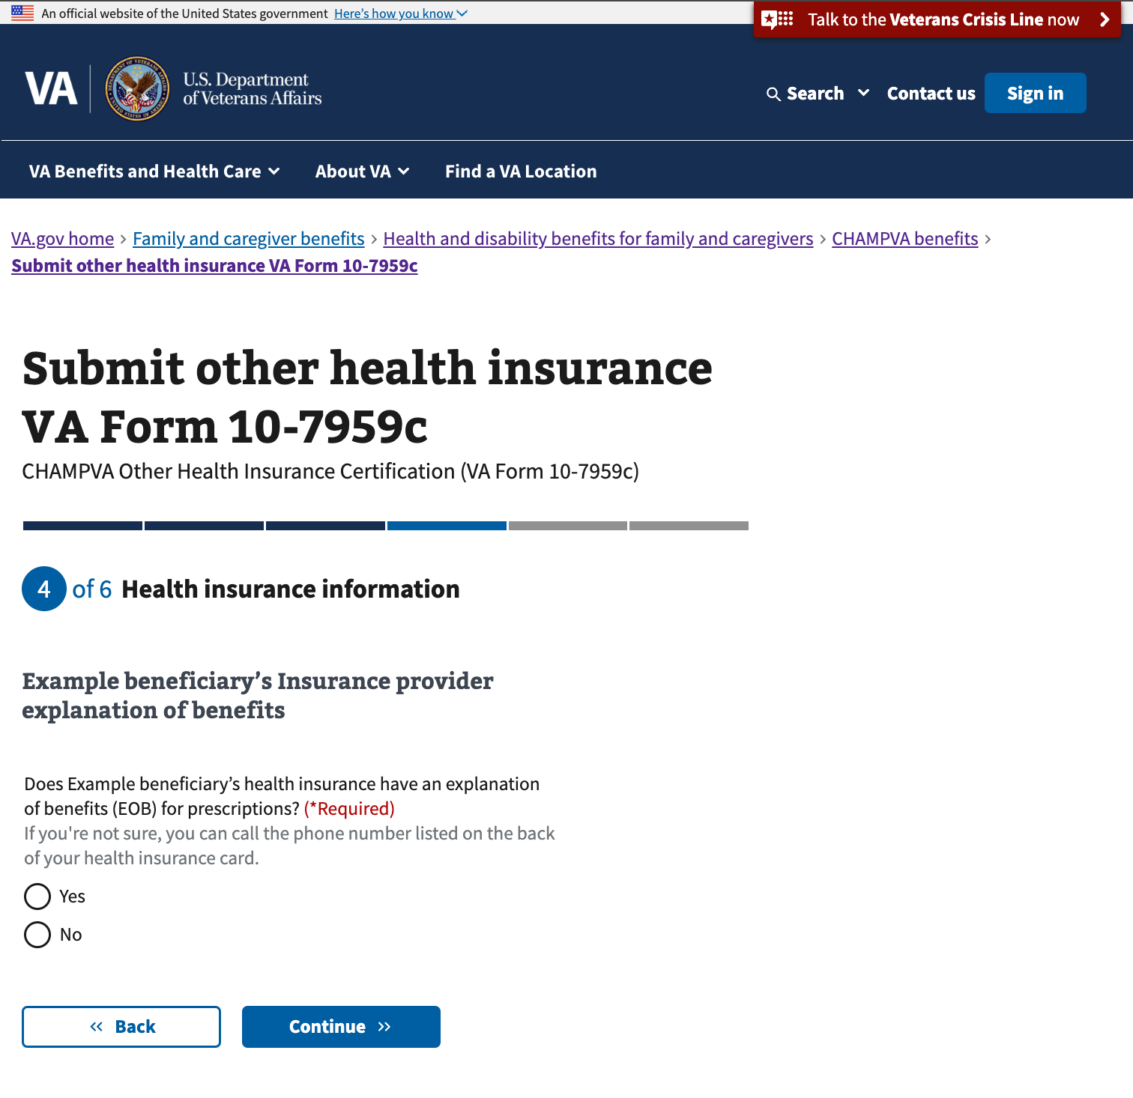

### Upload health insurance card

The user is prompted to provide a copy of their insurance card. This step is optional but will help with the processing of their form. They will also have an opportunity to upload later in the form if they choose.

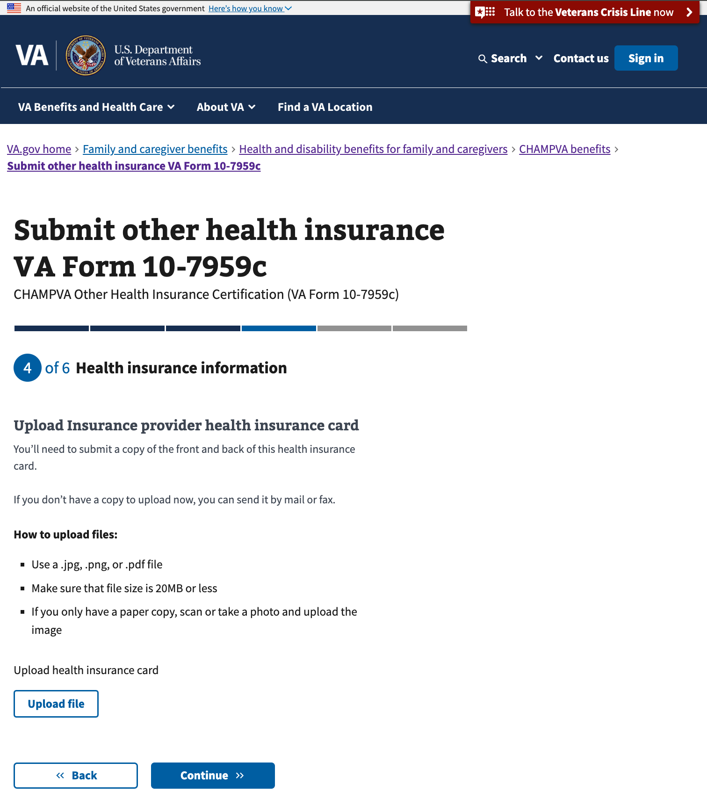

### Your health insurance additional comments

The user may enter any other information that is relevant about their insurance. The field has a limit of 200 characters.

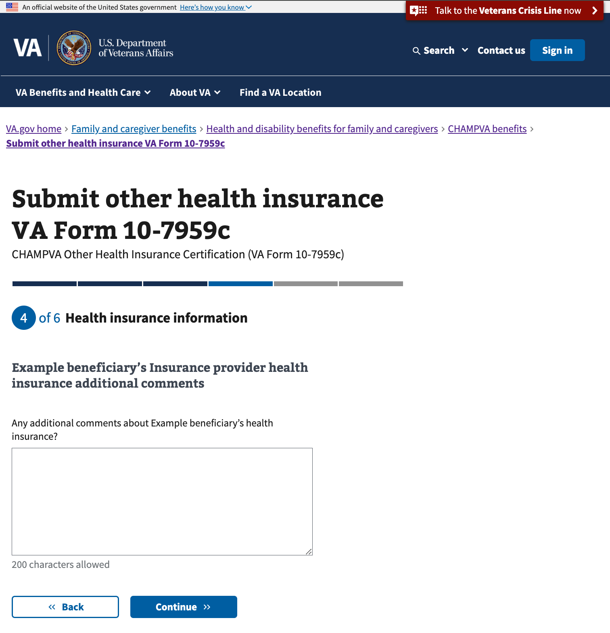

### Your additional health insurance

If the beneficiary has additional health insurance beyond that already entered, they can repeat the steps above for another provider to provide or update that information.

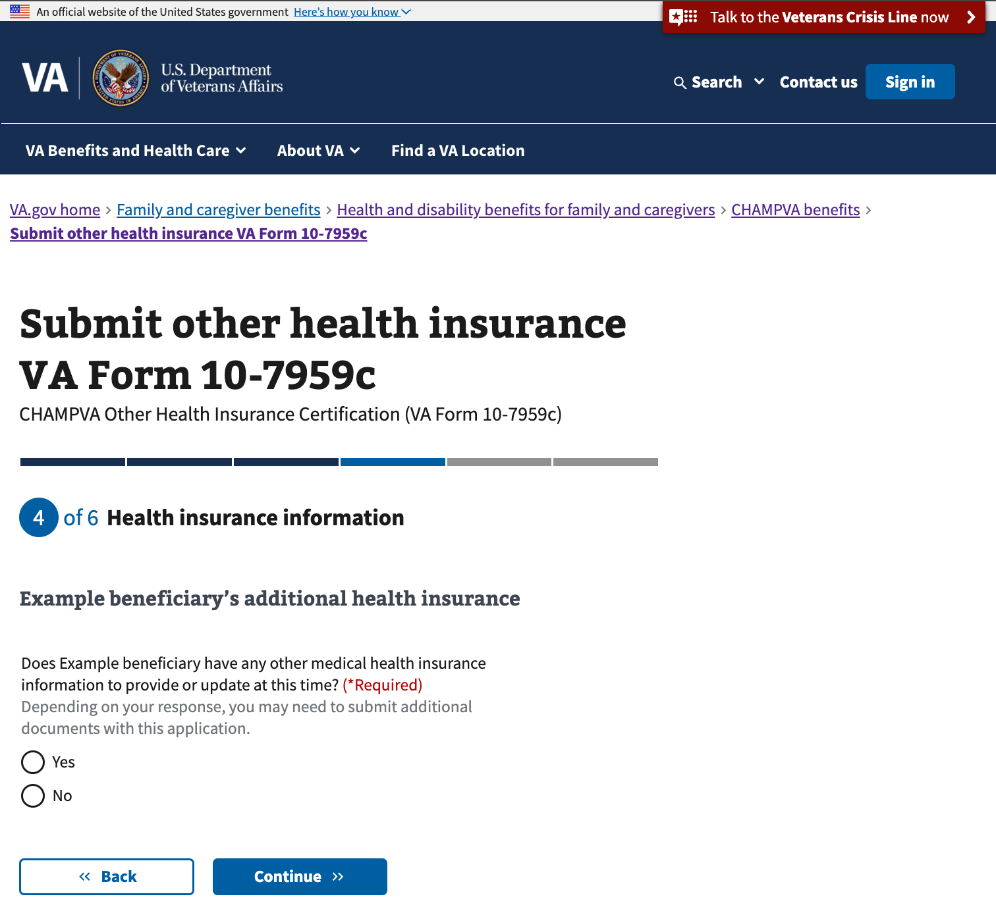

## Step 5: File Upload

### Upload your supporting documents

If the user has not yet uploaded their supporting documents, they will see a message for any document that is requested and have another opportunity to upload it on this page.

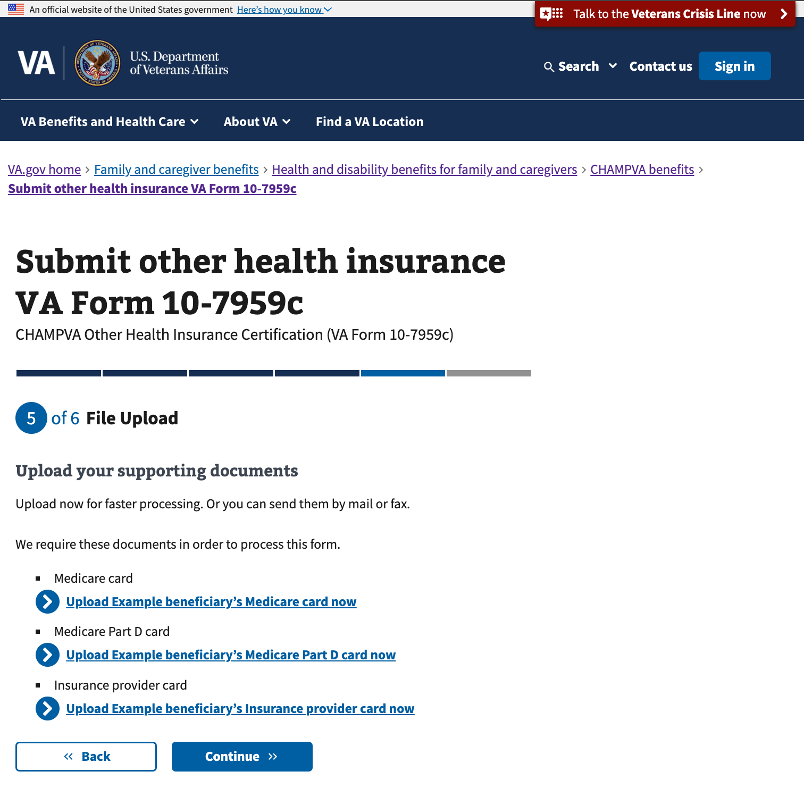

### Supporting documents summary

If the user does not upload documents that will be needed for processing, they are provided with information about those documents and asked to acknowledge their understanding of the potential impact on processing their form.

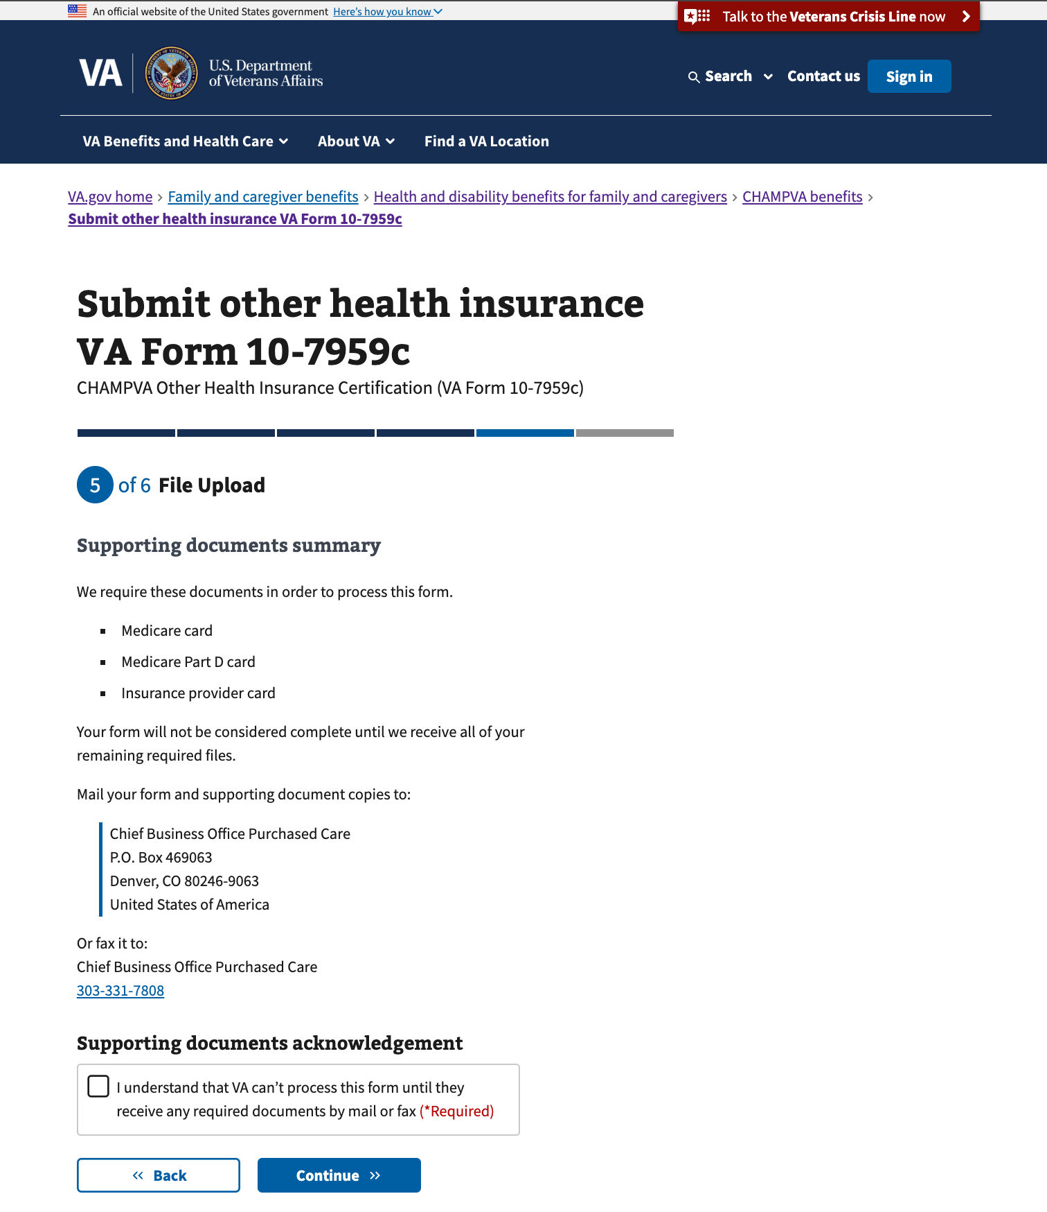

## Step 6: Review and sign

## 

The user can review their information, sign, and submit the form on this page. They can expand any section of the form to review their information by clicking on the plus sign on the right side of the review section.

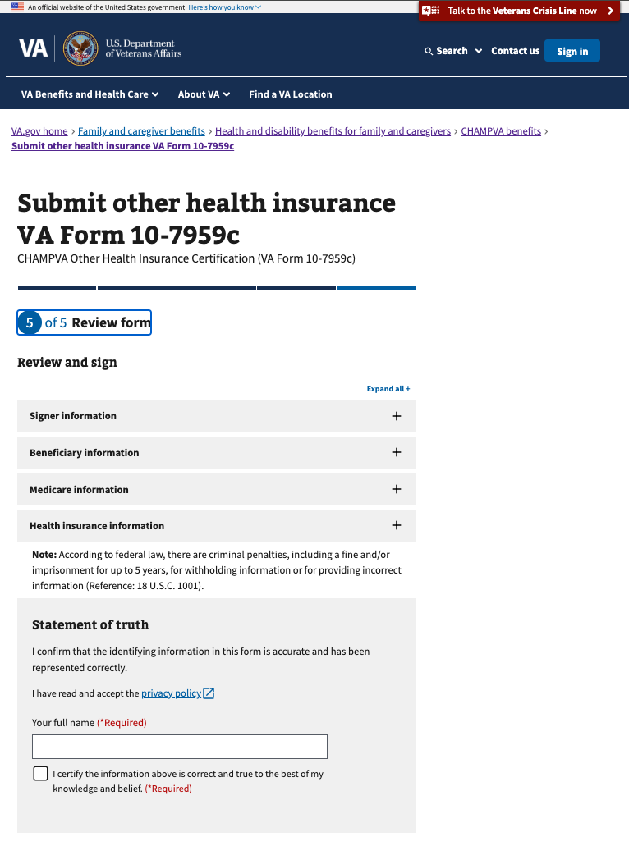

After submitting, the user should see a success message. Also see the “Error messages” section of this document for examples of what the user might see if their submit is not successful.

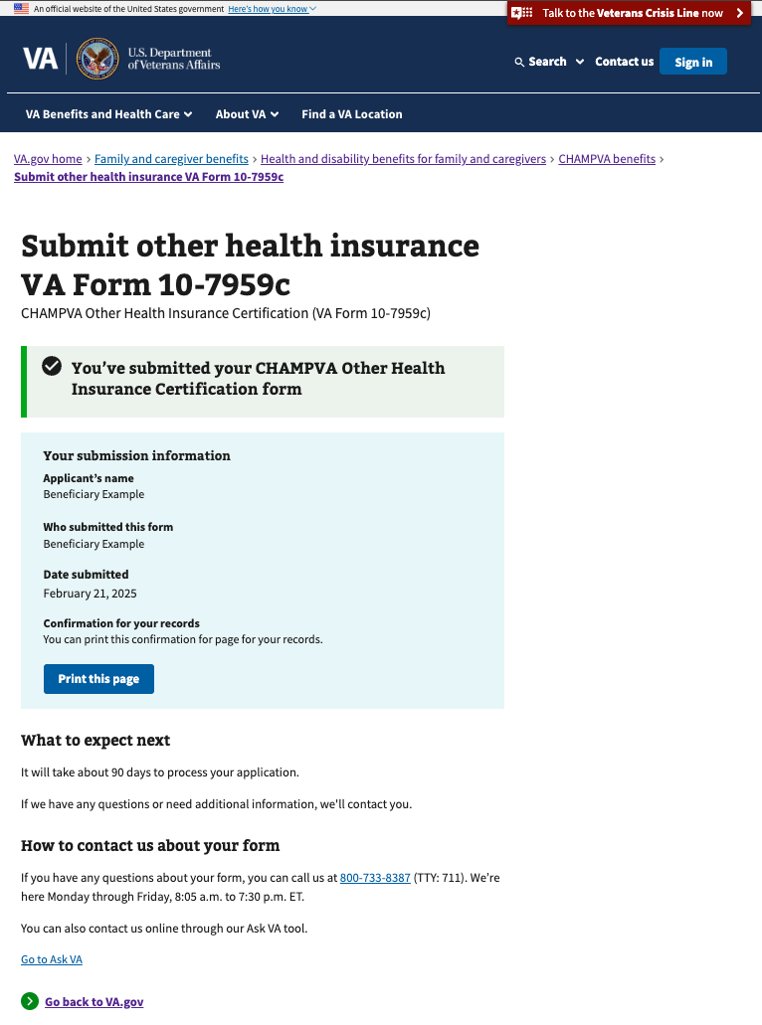

## Saved progress

If the user is signed in, their progress is saved automatically, along with their responses. If they want to leave and finish the form later, they can exit by clicking on the ‘finish this application later’ link.

If the user is signed in, when they return to the form url, they should be able to continue the form where they left off and see their saved progress.

The user can also click to start a new application, which will clear out any previously entered responses and start the form from the beginning.

## Error messages

On the review page, if there is an issue submitting, the user will see this error message. (They will be able to try to submit again from this page).

For any connectivity issues during submission, this error message appears.

Required fields that are missing a response will appear outlined in red.

